Map Book Generation

The purpose of the Map Book Developer’s Sample is to allow for the creation and output of map books. Map books are multi page documents based on a dataset and an index grid representing the pages. The Index grid for a map book represents how the dataset set should be divided up for plotting at a more workable scale. For instance, if a road atlas is being created, the index grid would represent the individual pages or the atlas. For a Land Records office, the index grid would represent the distribution of 1:400, 1:100, and 1:50 scale maps for the county.

To use these tools, the following pieces are needed:
- A dataset to output
- An index grid to divide up the dataset into pages (the grid may already exist as a feature class in your database, or the grid generation tool in the Map Book toolset can be used)
- A single layout to use with each page

Generally speaking, Map Books can contain multiple Map Series (set of pages based on a specific layer), title pages, and other pages with miscellaneous content. The set of tools describe in this document allow for the creation and persistence of a single Map Series within a Map Book. Additional Map Series, title pages, etc. would need to be created and stored in separate map documents. The objects used in generating the tools allow for storing these other components within a Map Book, so if you ambitious you may wish to expand the user interface and add these capabilities. Throughout the remainder of this document we will discuss how to use the tools to generate and use a Map Series within a Map Book.

Here are a few terms that will be used in this document:
- Index grid – refers to the feature class that will be used to divide your data up into pages. This feature class should contain polygon features with at least a string field representing the name to be used for each page. Additional fields may be added to represent the scale and data frame rotation to be used for the page represented by the feature. In other words, there is a one to one correspondence between the features in the Index grid feature class and the pages in your Map Series.
- Page – when you use these tools a “page” is generated for each feature in your Index grid. These pages become individual plots when you print your Map Series, or individual files when you export.
- Tile – refers to the individual features of your Index grid. More or less synonymous with a Page.
- Map Series – a collection of pages based on the same layout. This is what the set of tools being discussed in this document allow you to create.
- Map Book – a collection of Map Series and other miscellaneous pages.

Installation

To install the toolset, double-click on the _INSTALL.bat file. This file will register two dlls (DSMapBookPrj.dll and DSMapBookUIPrj.dll) and load the necessary classes into the correct component categories. See the Object Model section below for more information on the components in the dlls.

Generating an Index Grid

Before creating a Map Series, you first need an Index Grid to base your pages on. If you already have a grid for your dataset, proceed to the next section (Generating a Map Series). The grids you use don’t have to be of any particular size and shape, nor do they need to be interconnected. The grid features just need to be polygon shapes. The Index grid you use must contain a field with string values representing the name of each page (tile). If you do not have a predefined Index grid, the steps below can be followed to generate one.

Begin by starting ArcMap and turning on the Map Series toolbar. Click on the Create/Update Map Grids tool to display the dialog.

Generating a Map Series

Along with an Index grid, a page layout is necessary to generate a Map Series. If you don’t already have a page layout created, standard ArcMap tools can be used to generate one. Refer to the ArcMap help for the steps involved in adding legends, north arrows, and other map surrounds to your layout.

Once you have an Index grid and a layout loaded into your ArcMap session, you are ready to create a Map Series. If the Map Book tools are probably registered, an additional tab called “Map Series” should be available on the Table of Contents. If the tab is not available, go to the Tools->Options dialog and enable the tab.

The wizard for creating a Map Series can be accessed by either selecting the Create Series tool on the Map Series toolbar, or by right clicking on “Map Book” on the top of the Map Series tab and selecting Create a Series. Both options lead to the display of the wizard.

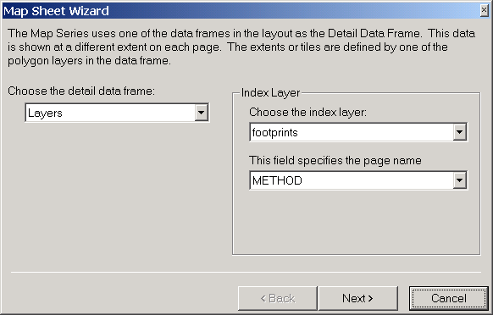

Figure 1 shows the first page of the wizard. On this page you are required to specify the data frame were the content for the Map Series will come from. It is important to note here that while it is possible to have multiple data frames in your layout, the tools for generating the pages in your series will only update the display for a single frame (not counting the Identifier frames that we will discuss later). For this reason it is recommended that only one data frame be used.

In addition to specifying the data frame, the first page of the wizard is also used to specify the layer representing your Index grid and the field from that layer containing the name for each page (tile). Your Index grid needs to be in your ArcMap session to be used for generating a Map Series, but it does not have to be visible.

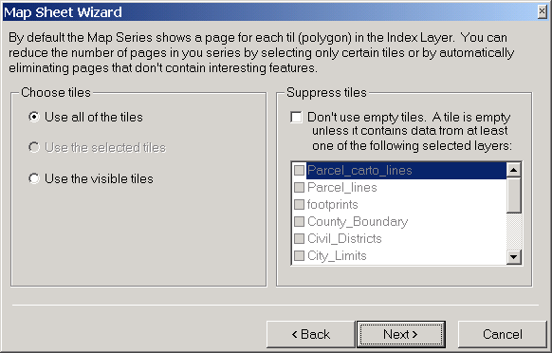

Figure 2 shows the second page of the wizard, which is used for determining which tiles (features) of your Index grid will have pages generated for them. The left side of the page allows you to specify whether all or a selected number of tiles will be considered, while the right side of the page is used to eliminate tiles based on the discovery of features from designated feature classes on those tiles. For instance, if I am creating a Map Series of parcels for my county, I would probably choose to exclude tiles that did not have any parcels on them. This can be accomplished by clicking on the suppression option and choosing the parcels layer from the available list. Keep in mind that querying each tile for the availability of features from a particular feature classes can be a time consuming process (based on the amount of data in your database), so you probably do not want to turn on more than one or two feature classes for suppression.

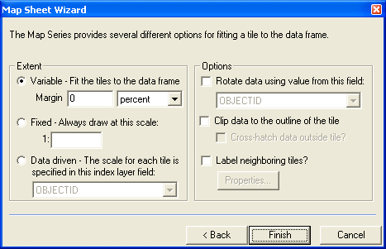

Figure 3 displays the final page for the wizard, which is for specifying the options to use with your Map Series. The selections on the third page of the wizard can be changed once the Map Series has been created, while the choices on the first two pages can not.

The left side of the third page is for specifying how the map extent (scale) will be set for the individual pages. The three options are as follows:
- Variable – with this option the extent will be set to the envelope of the tile feature plus any margin you specify. With this option the scale of each individual page in your box will be different if your tiles are not of uniform size.
- Fixed – with this option the scale of each page will be what you specify and there will be no variation between pages.
- Data Driven – This option should be used when you have specific scales that go with each page (tile) in your series. To use these values you need to have an attribute field on the Index grid containing the scale (this field needs to be defined as a numeric field). For instance, using our Land Records example before where the county is divided up into 1:400, 1:100, and 1:50 scale maps. In this case each tile in the Index grid would have an attribute value set equal to 400, 100, or 50.

The right side of page three has some additional options you can set:
- Rotation – this is also an attribute driven option. If you want to apply rotations to the data frame on each individual page, then you need to have a numeric field on your Index grid that contains these values. An example of when this option would be used is a during the mapping of a highway or some other long features in which the tiles of your Index grid were generate to allow for output of this feature at a particular scale.
- Clip – turn on this option if you want the data to be clipped to the shape of your tile. Additional checkout can be used to display a gray crosshatch over the area outside of the current tile as opposed to not displaying it at all.
- Labeling Adjacent Tiles – there are multiple ways you can identify the tiles that are adjacent to the tile represented by the current page. One way is through Identifier frames (which we will discuss later), and the other is through this option. The Labeling option will add text around the outside of the data frame to indicate the tiles that are adjacent. These text elements are updated for each individual page.
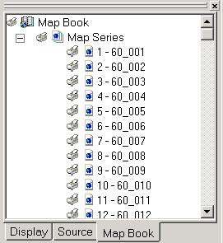
After you have specified your options on the third page of the wizard, select the Finish button and the Map Series will be generated. The individual pages of your series will be displayed on the Map Series tab based on the attribute value from the field you specified on the first page of the wizard. Double-click on a page (or right-click and select the View Page option) to see how that individual page looks.

The Figure to the left shows the Table of Contents after a Map Series has been created.

The page layout you have defined does not change as you switch between the different pages in your series. You can update the layout at any time, as this information is not currently stored with the series. However, there are a couple of extra things you can add to your layout through this toolset that can add some additional page specific information. The next section (Adding Page Specific Elements) discusses these items.

Adding Page Specific Elements

In general, switching between the pages in you Map Series doesn’t do much more than update the extent of the data displaying in the data frame (and change the labels for adjacent tiles if you have activated this option). There are a few additional items you can add to your layout that will be updated on a page by page basis, though. These items are:
- Date – will be updated to the current date each time a page is generated.
- Title – will be updated to the name of the page when the page is generated.
- Extra Item – will be updated based on the value in the specified field from the index layer
- Identifiers (Local and Global) – these show the position of the page being shown in relation to the other pages/tiles. The purpose of the Local Identifier is to show those pages that are adjacent to the current page, while the Global Identifier shows all the pages/tiles with the current page highlighted. Both of those options create an additional data frame so you can change the highlight color, label properties, and so on.

To create a Date, Title, or Extra item, begin by adding a Text Element to your map at the appropriate position, size, color, etc. With only this element selected, select either the Tag as Date, Tag as Title, or Tag With Index Layer Field choice from the context menu for the Map Series (accessed by right clicking on the Map Series entry in the Table of Contents). Items tagged as dates will be updated with the current dated after tagging. Items tagged as titles will have their string changed to “Title String” to let you know they have been tagged. The name of the page will be inserted the next time you access one of the pages. Items tagged with a field from the index layer will be updated to the attribute value from the specified field for the current tile/page.

For the Identifiers, choose the Add Identifier Frame button on the Map Book toolbar. You will be presented with a dialog that asks you whether you want to add a Local or Global Identifier. Make your selection and click on the OK button. At this point the Identifier tool will be active, so you need to drag out a box on the layout to identify the position for the Identifier Frame. After you drag out a box the frame will be added to your layout. Select the Identifier Layer from the Table of Contents on the Local Indicator or Global Indicator frame (depending on which type of Identifier you added) and change the selection symbol, label characteristics, etc. as you see fit. You will need to select on one of your pages to update the Identifier for the first time.

Below is an example of a Local Identifier.

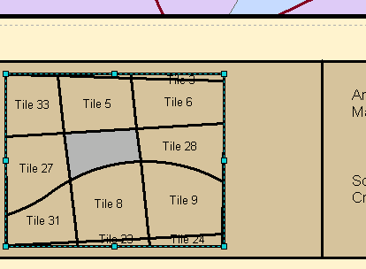

Printing and Exporting

Printing and exporting can be done for a single page, a set of pages or the entire series. Print and Export options are available by right clicking on any of the items for the Map Book in the Table of Contents. The context menu you choose from depends on the number of pages you want to export. The available options are:
- To output a single page, you would access the context menu for that page and select either Print Page or Export Page.
- To output a series of pages, you would access the context menu on the Map Series you created and select either Print Series or Export Series. The dialog that appears after selecting from the Map Series context menu allows you to specifically specify the pages you want to output, or you can choose to output the pages you have enabled by some other method (more on the enabling of pages later).
- To output all the Pages in your Series, you can either access the print and export dialogues from the Map Series context menu and select “All”, or access the context menu from the Map Book and select Print Map Book or Export Map Book. The options on the Map Book context menu only allow you to print all of the Pages.

The Print dialog appears below:

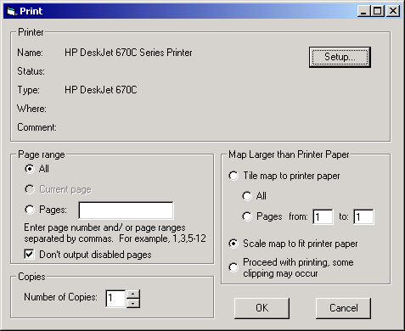
Depending on the context menu you used to display the dialog, the available Page range options will vary. Current page is the only option when the dialog is activated from the context menu of an individual page. All and the Pages: option are available when the dialog is activated from the Map Series context menu. All is the only available option when the Map Book context menu is used. When selecting the All and Pages options, the “Don’t output disabled pages” checkbox can be used to further limit the pages. If a page is disabled (not available for output), then it will not be printed or exported when this checkbox is checked.

The Export dialog appears below:

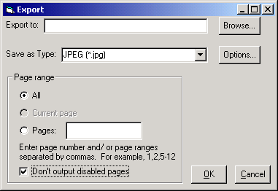
The Page range options on the Export dialog operate in the same manner as those on the Print dialog.

When a page is exported or printed, the Last Output value for the page is updated to the current date. To view the Last Output date for your pages, select Page Properties from the Map Series context menu. This information is stored as a parameter of the page within your document. As a result, you should always make sure to save your Map Document after printing or exporting to insure your dates are maintained. These dates can be used in selecting pages to print or export as discussed in the next section.

Creating Feature Indexes

A recently added option to the Map Book code is the ability to create an index for the features in your database (i.e., a street index). This option is available by selection the “Create Series Index …” option from the Map Series context menu. When this option is selected the following dialog is displayed:
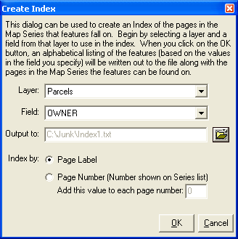

The dialog allows you to select a layer in your map, a field (text fields only) from that layer, and an output text file. When you click on the OK button an alphabetical listing of the attribute value from each feature in the specified layer will be written out to the file along with the Pages the feature falls on. Based on the dialog to the left, a file will be written out containing the OWNER names of each feature in the Parcels layer with the Pages these features are on. If you use a Street layer with a StreetName field, then you will get an alphabetical listing of the streets and the map sheets you can find those streets on.

The Index by: option allows you to specify whether the Page label (the name of the page/tile) will be listed or the number corresponding to the page (as shown on the Map Book tab in the ArcMap Table of Contents). With the number option you can also add an additional value in case you want the page numbering to begin at something other than 1.

Enabling and Disabling Pages

Pages are enabled and disabled for output purposes only. Disabling a page does not mean it is not available for display, it just means that it can be excluded from output (when the “Don’t output disabled pages checkbox is used on the Print and Export dialogues). The purpose of this capability is to give you another method for specifying the pages to be output. The simplest way to enable or disable a page is to click on the icon at the left of the page entry. This icon will be a printer if the page is enabled, or an “X” if the page is disabled. Click on the icon will toggle it between the two options. This same thing can be accomplished by either selecting Enable Page or Disable Page from the context menu for the page.
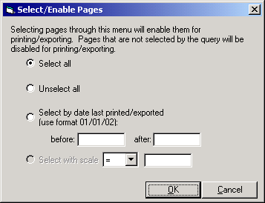
Another method for enabling and disabling pages for output is to use the Select/Enable Pages dialog which can be accessed from the Map Series context menu. This dialog can be used to select pages for output before executing the Print or Export dialog. The dialog is as follows:

The Select all and Unselect all options are used to select/enable or unselect/disable all the pages. The Select by date option is used to select pages based on their Last Output parameter (you can see this date for the pages in your Map Series by selecting the Page Properties option on the Map Series context menu). Specifying a date in the before: box will select all those pages that have not been printed since the specified date. Specifying a date only in the after: box will select all those pages that have been printed since the specified. Places a date in each box will cause those pages printed between the two to be selected/enabled. If you are setting the Scale for your pages based on an attribute value, the Select with scale option will be enabled. This option will allow you to select pages =, <, <=, >, or >= the specified scale.

Context Menu Options

Right clicking on any item on the Map Book tab in the Table of Contents will give you a context menu. Depending on what you click on you will be present with a different set of choices. The context menu for a Map Book looks like this:

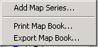Add Map Series – Opens up the wizard for generating a new Map series.
Print Map Book – Opens up the dialog for printing all of the pages in your book.
Export Map Book – Opens up the dialog for exporting all of the pages in your book.

The context menu for a Map Series looks like this:

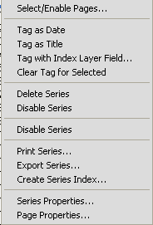 Select/Enable Pages – Opens up the dialog for selecting/enabling pages based on a query of the Last Output date or the Scale for the page (select and unselect all also available).
Tag as Date – tags the selected Text Element, so that it is updated with the current date each time the page is activated or output.
Tag as Title – tags the selected Text Element, so that it is updated with the name of the page/tile each time the page is activated or output.
Tag with Index Layer Field – tabs the selected Text Element with a field from the index layer. Element is updated with value from current tile/page.
Clear Tag for Selected – Clears any tags that have been set on the selected text elements.
Delete Series – deletes the series
Delete Disabled Pages – removes the currently disabled pages from the series.
Disable Series – disables the entire series.
Print Series – Opens up the dialog for print pages in the series.
Export Series – Opens up the dialog for exporting pages in the series.
Create Series Index – Opens up a dialog for creating an index based on the features that fall on each tile (i.e., a street index).
Series Properties – Brings up a dialog showing the properties of the series. Only the options for the series can be changed.
Page Properties – Brings up a dialog showing the Name, Scale, Rotation and Last Output values for the pages in the series.

The context menu for a Page looks like this:

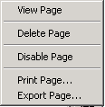View Page – activates (displays) the page.
Delete Page – removes the page from the series.
Disable Page – disables/enables the page. This option is used to limit the pages that are output when you Print or Export from the Map Series context menu.
Print Page – allows printing of the individual page.
Export Page – allows exporting of the individual page.

Creating an Index (Grid) Layer

The Grid Generator Wizard is a tool for creating Map Grid polygons that can be used with the other Map Series tools. You can optionally populate an existing feature class (personal geodatabase or shapefile), or create a new feature class from scratch. The options available when generating your grid polygons are explained more fully below.

One technical note about generating an index grid layer is that the calculation that converts a Map Scale (eg: 1:1,000) and a Paper Size (eg: 8½” by 11”) into actual polygon grid features (eg: 250 ft by 300 ft) requires certain information about the data’s projection. For Projected data (eg: UTM14N), the MetersPerUnit property is used to make this calculation. However, for non-projected Geographic data (eg: lat/long) we don’t have this property (as the ratio of meters to decimal degrees varies depending where you are on the globe). To support grids in Geographic format, a “flat” calculation is made - where the current data extent and map scale are used as a direct ratio for the created grids. This ratio can only be calculated while in Layout View, so the Grid Generator Wizard button will only be enabled for Geographic data when switched to Layout View.

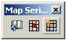
Figure 1

Figure 1 shows the Map Series toolbar. The Grid Generator Wizard is the third tool.

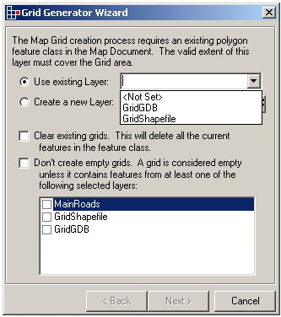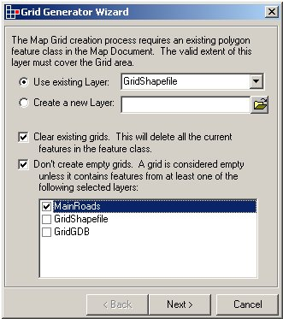
Figure 2 Figure 3

The first step in the wizard is setting where the created grids will be stored. Figure 2 shows how the wizard will start, with no options selected and all the current Polygon Layers listed in the top combo box. Note that the Next button is disabled.

Figure 3 shows the completed options. In this case we are going to store the new grids into a layer already loaded in ArcMap. We’re also going to delete all features that are currently in that layer and we’re only going to create grids if they contain one or more MainRoads features in them. Note that any Definition Query defined upon the selected layers will be adhered to, so you could make grids for specific areas (eg: Tax Zones), specific linear features (eg: Transmission Lines) or specific points (eg: Site Offices).

You cannot continue to the next step until you specify the output layer. If you opt to ignore empty grids, you will need to specify at least one overlay feature layer as well.
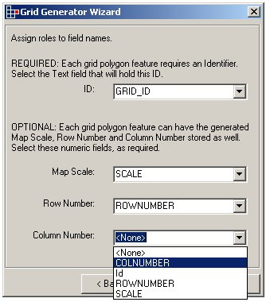
Figure 4

Figure 4 shows the second page of the wizard. Here is where you specify the fields in which you want to store attributes about the generated grids. The only required entry is the ID field. This is a string field that will store the unique identifier for each grid polygon created. (You specify the format of the Identifier later on). The wizard will list all the available string fields in the combo box.

There are also three optional output field settings. You can use none, one, two or all three of them, depending on your data modal and individual requirements. All three fields are numeric, and only these types of fields will be listed in the combo boxes. You can also not select the same field for different attribute roles. The Map Scale field will store the scale each grid will be created for (set later on in the wizard). This is useful if you are planning on storing multiple scale grids in the same feature class. The Row and Column Number fields will store the row/col values for each grid, regardless of the Identifier format used. This provides access to absolute grid positions should you ever need to change the Identifier format programmatically at a later stage, or if you want to use the grids as navigation aids.

Note: if you are creating a new shapefile or feature class to store your grids, then this page will not appear. The wizard will define and create all the fields for you.

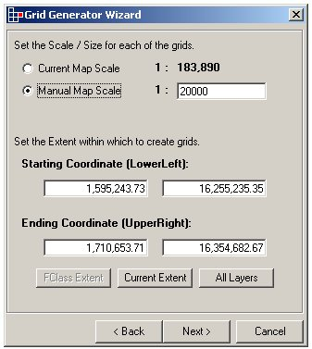
Figure 5

The third step in the wizard is defining the scale at which the grids will be displayed when used in conjunction with the other Map Series tools. In the above example we are creating 1:20,000 scale grids. The scale must be greater than 0.

A related requirement is the range within which to create the grids. By default, the dialog will be populated with the current map extent. You can use the provided buttons to set the bounding coordinates to the extent of the destination feature class, the current extent, or the extent of all the layers in the Map. Note that if the destination layer is a shapefile, then it doesn’t have a defined extent (as geodatabase feature classes do) and therefore the button is not always available. You can also edit the values directly within the text boxes. If a value is entered into a text box that is outside the valid range of the destination feature class then the text will be turned red and you cannot continue.

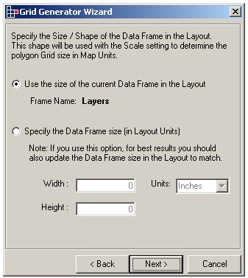
Figure 6

Next, you need to specify the shape for the grid polygons created. We calculate this shape based on the Data Frame that is going to display the final grids. By default, this is set to the current Data Frame, the name of which is displayed on the dialog. You can optionally define the Data Frame size manually. This is done in Layout units (usually Inches or Centimeters). This is useful if you are creating the grids on a machine that does not have the final Layout defined on it – you can simply specify the size of the output map frame and the grids will be created accordingly. In figure 6, above, we are going to accept the current data frame, “Layers”, as our grid shape. The actual calculation converts the Layout units at the given scale into map units for the grid polygon’s height and width.

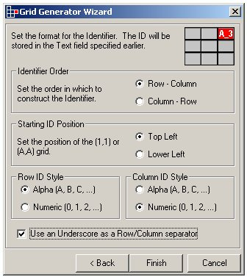
Figure 7

The final step is to set the Identifier format. Essentially the identifiers created are a concatenation of the row and column numbers, with several formatting options. You can change the order the identifiers are joined together, where the starting grid is, the style of row/column Ids, and whether or not to separate them using an underscore. As the settings are changed, the example Identifier in the top right hand corner of the dialog is updated. In Figure 7, above, we can see the example Identifier is set to ‘A_3’.

The Finish button will then create your grids. You can cancel the map grid creation during processing, if required. The cancel process will allow you to: keep the grids created thus far; rollback to where you were before you started; or cancel the cancel and continue creating grids.

Figure 8, below, shows the grids produced based on the example settings specified above.

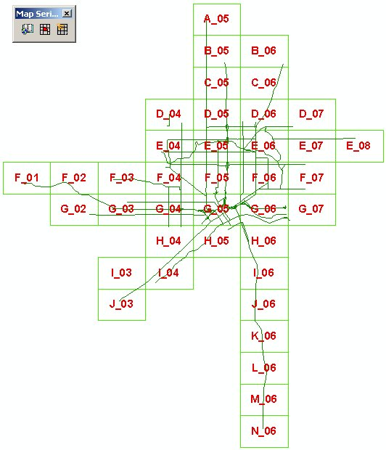
Figure 8

Creating a Strip Map Grid Layer

A Strip Map, in regards to this tool, is a connected series of maps that follow some sort of logical path across data. The Strip Map Generator Wizard is a tool for creating a connected path of Map Grid polygons that can be used with the other Map Series tools. You can optionally populate an existing feature class (personal geodatabase or shapefile), or create a new feature class from scratch. The options available when generating your strip map grid polygons are explained more fully below.

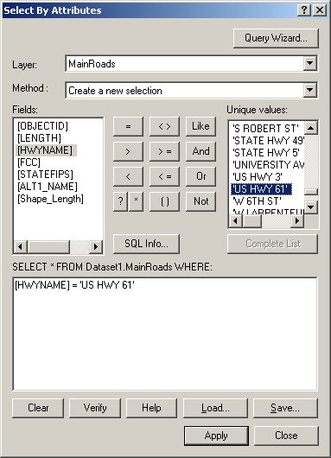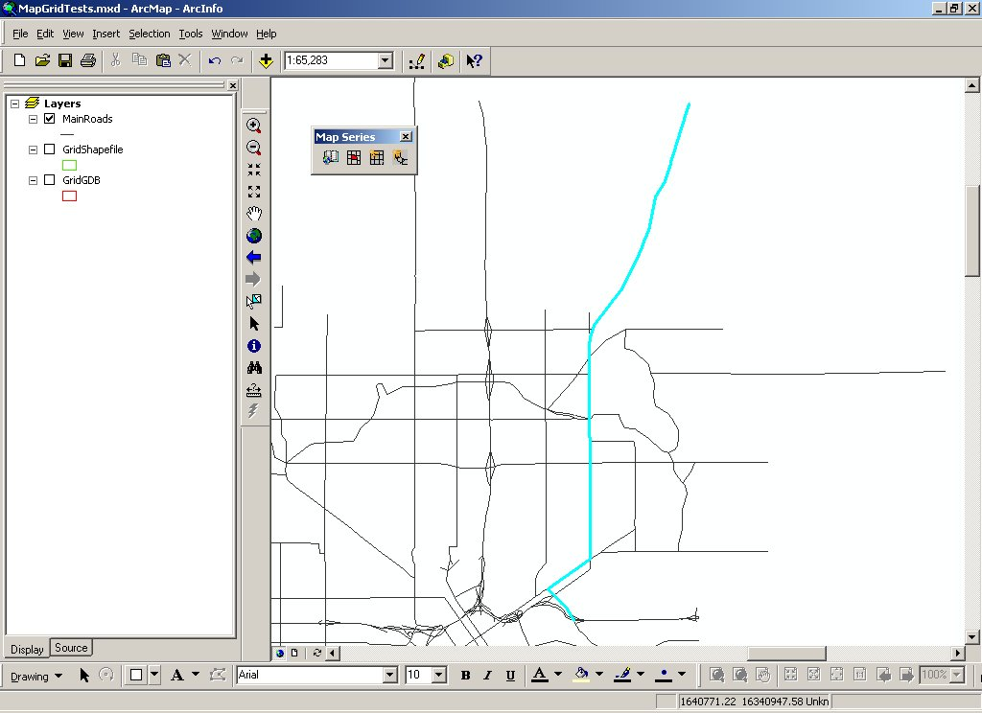
Strip Map Path
Figure 1 Figure 2

The first step in generating a Strip Map is to define the path to follow. The way this is done for the Strip Map Generator is via a selection set. Figures 1 and 2 above show one method of selecting the path. That is, via an attribute selection. Other methods, such as a network trace, manual selection, etc, are equally valid. The tool just requires a selected path when it is invoked. Note that forked and disjoint paths are not supported at this time. Looped paths are only supported if a single, looped polyline is selected.

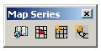

Figure 3

Figure 3 shows the Map Series toolbar. The Strip Map Generator Wizard is the fourth tool. Once you have defined the selection for the Strip Map, open the Wizard via this button.

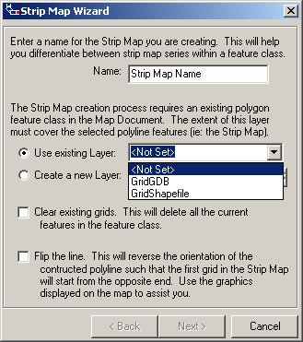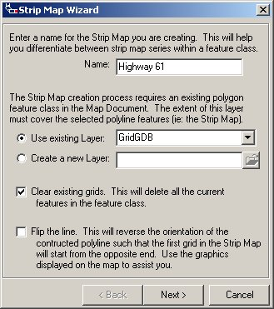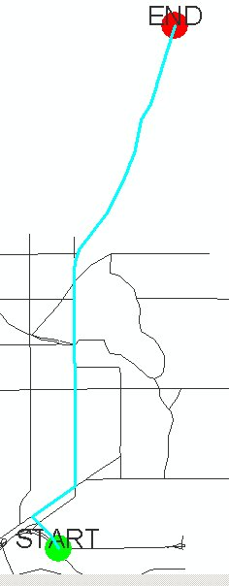
Figure 4 Figure 5 Figure 6

The first step in the wizard is setting where the created grids will be stored. Figure 4 shows how the wizard will start, with no options selected and all the current Polygon Layers listed in the existing layers combo box. Note that the Next button is disabled.

Figure 5 shows the completed options. In this case we are going to store the new grids into a layer already loaded in ArcMap. The name for the Strip Map Series is going to be ‘Highway 61’ and we’re going to delete all features that are currently in that feature class. Note that by opting not to delete existing grids in the output feature class you can define many Strip Maps in a single feature class and then reference them by name for plotting purposes.

Figure 6 shows the temporary graphics that are created on the map when the dialog is opened. It shows which end of the path the Strip Map will begin from. In this case, the map series will begin from the south and head north. If we wanted to create the Strip Map in the other direction we could check the ‘Flip the line’ option.

Note that you cannot continue to the next step until you specify the output layer.

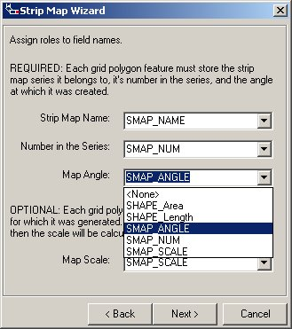
Figure 7

Figure 7 shows the second page of the wizard. Here is where you specify the fields in which you want to store attributes about the generated strip map grids. The required fields are: Strip Map Name, Number in the Series, and Map Angle. The Strip Map Name must be a string field that will store the name for each grid polygon created. The Number in the Series and Map Angle values must be stored in a numeric field, with grid numbers starting from 1 and angles being stored in degrees. The Map Angle is important as it interacts with the Map Book options used when generating hard copy maps. The wizard will list all the available fields (based on applicable field type) in the combo box for each attribute.

There is also one optional output field. The Map Scale field will store the scale each grid will be created for (set later on in the wizard) and is numeric. Again, only the available numeric fields will be listed in the combo box. You cannot select the same field for different attribute roles.

Note: if you are creating a new shapefile or feature class to store your grids, then this page will not appear. The wizard will define and create all the fields for you.

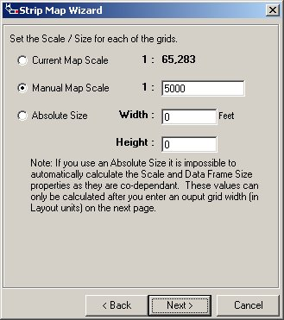
Figure 8

The third step in the wizard is defining the scale at which the grids will be displayed when used in conjunction with the other Map Series tools. In the above example, Figure 8, we are creating 1:5,000 scale grids. The scale must be greater than 0.

Optionally, we can avoid Scale altogether and set the grid size based on real world units. For example, you may want grids that are 400 feet wide and 250 feet high. In that case, select the Absolute Size option and enter the values in the text box. The current Map Units are used for any values entered. The name of the current Map Units is displayed in the label next to the Width text box. Note that as the Grid Size, Data Frame Size and Map Scale are mathematically dependant upon each other, you cannot set the scale and size properties simultaneously. The scale value will be calculated based on the data frame size set in the next step.

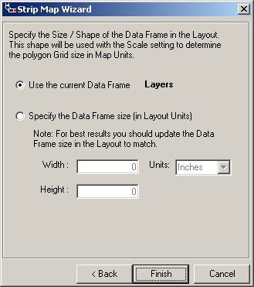
Figure 9

The final step is to specify the shape for the grid polygons created. We calculate this shape based on the Data Frame that is going to display the final grids. By default, this is set to the current Data Frame, the name of which is displayed on the dialog. You can optionally define the Data Frame size manually. This is done in Layout units (usually Inches or Centimeters). This is useful if you are creating the grids on a machine that does not have the final Layout defined on it – you can simply specify the size of the output map frame and the grids will be created accordingly. In figure 9, above, we are going to accept the current data frame, “Layers”, as our grid shape. The actual calculation converts the Layout units at the given scale into map units for the grid polygon’s height and width.

Note that if we have specified a specific grid size on the previous step (ie: Absolute Size), then the Scale will be calculated instead.

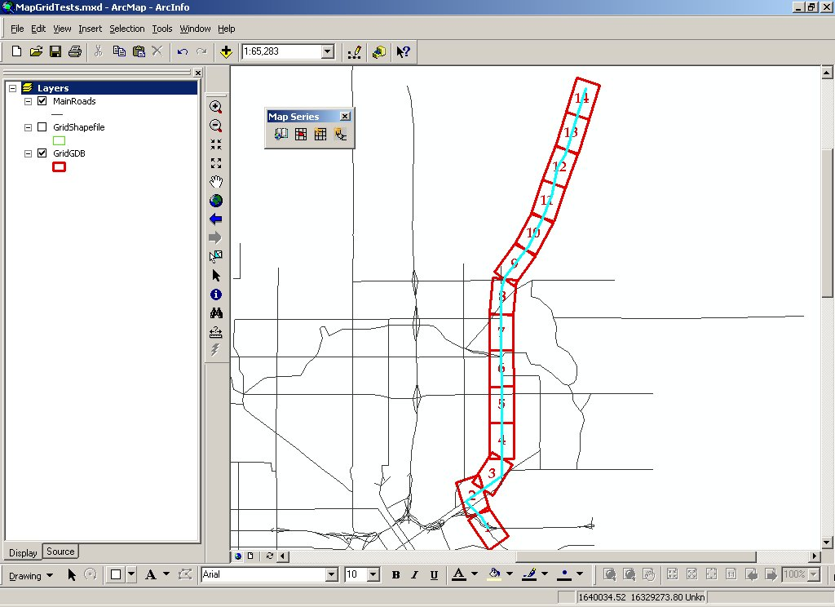
Figure 10

Figure 10 shows the results of our settings. We can see that the start of the Strip Map is in the south and that it progresses northwards, as specified. We can also see that this tool supports complex connections, obvious in the link between grids 2 and 3. The tool calculates the place on the previous grid where the path exits the polygon and then uses that as the start point for the next grid. The rest of this particular Strip Map is more standard, where the grids appear like a connected snake.

Final tip: While this tool, in its current state, does not support buffered areas around each grid, this effect can be achieved via options available in the plotting dialogs. For example, if you wanted a 1:1,000 Strip Map that included a 10% buffer, you can generate the base grids at 1:909.091 and then add the 10% buffer in the Map Book dialog. That is, 909.091 * 1.1 = 1000 (to 4 decimal places).

Object Model

The Visual Basic code for the Map Book is divided into two separate projects. The first project contains a set of objects (along with their properties and methods) that are used in the second project to create the user interface. The first project is called “DSMapBookPrj.vbp” and it contains the DSMapBook, DSMapSeries, and DSMapPage objects along with the interfaces for each. The interfaces, properties, and methods for these objects are as follows:

DSMapBook:
IDSMapBook:
AddContent (Content as object) – allows additional content to be added to the book. For the application portion of this implementation, only a single series is added to the Map Book. However, the hooks are there for you to add additional content to the book.
ContentCount: Long – returns a count of the content items in the book.
ContentItem(Index as Long): Object – returns the content item (as an object) at the specified index.
EnableBook: Booean – returns/sets whether the book is enabled for output or not.
RemoveContent(Index as Long) – removes the content at the specified index.

DSMapSeries:
IDSMapSeries:
AddPage (Page as IDSMapPage) – allows additional pages to be added to the series.
EnableSeries: Boolean – returns/sets whether the series is enabled for output or not.
Page (Index as Long): IDSMapPage – returns the page item at the specified index.
PageCount: Long – returns the number of pages in the series.
RemovePage (Index as Long) – removes the page at the specified index.
IDSSeriesOptions: the properties in this interface can be changed after a Map Series has been created. Changes will be enforced the next time a page/tile is displayed.
ClipData: Boolean – returns/sets whether pages in the series will be clipped based on the geometry of the page/tile.
DateDrivenField: String – returns/sets the name of the field to be used when the scale for each page is coming from an attribute value on the Index Layer.
ExtentType: Long – returns/sets where the scale is coming from when a page is displayed or output. 0 specifies a best fit scale, 1 specifies a constant scale, and 2 specifies that the scale is coming from an attribute value.
FixedScale: Double – returns/sets the scale to use for each page when a fixed scale is being used.
LabelNeighbors: Boolean – returns/sets whether adjacent pages/tiles are labeled on the layout.
LabelSymbol: ISymbol – returns/sets the symbol to be used in label the neighboring pages/tiles.
Margin: Double – returns/sets the margin to add when a best fit option is being used to set the scale for each page/tile.
MarginType: String – returns/sets how to apply the value of the Margin property. The two options are percent (the Margin value should be the percent to add to the current scale) and map units (the number of Map Units to add to the current scale as a Margin).
RotationFrame: Boolean – returns/sets whether the frame should be rotated for each page/tile based on an attribute value on the Index Layer.
RotationField: String – returns/sets the name of field on the Index Layer to use when rotating the pages/tiles.
IDSSeriesOptions2: added with the new option to display crosshatch over areas outside current tile (as opposed to clip).
ClipData: Long – returns/sets whether pages in the series will be clipped based on the geometry of the page or have gray cross hatch drawn on top of area outside current tile/page. Values are 0 for no clip at all, 1 for clip, and 2 for crosshatch.
IDSSeriesProps: the properties in this interface are only used when a Map Series is initially created.
AddLayerToSuppress (LayerName as string) – add a layer to the list of layers to use when determining the pages/tiles to suppress. Pages/tiles are suppressed when the suppression option is selected and no data from any of the layers in the suppression list can be found on the page.
DateFrameName: String – returns/sets the name of the data frame used in the Map Book.
IndexFieldName: String – returns/sets the name of the field containing the name of each page/tile.
IndexLayerName: String – returns/sets the name of Index Layer to be used in generating the Map Series.
RemoveLayerToSuppress (Index as long) – removes the layer at the specified index from the suppression list.
SuppressLayer (Index as Long): String – returns the name of the suppression layer at the specified index.
SuppressLayerCount: Long – returns the number of layers in the suppression list.
SuppressLayers: Boolean – returns/sets whether suppression is used in the creation of the Map Series.
TileSelectionMethod: Long – returns/sets how tiles are selected during the generation of the Map Series (this is separate from suppression). 0 indicates all tiles/pages will be generated, 1 indicates only the selected tiles/pages will be generated, and 2 indicates only the tiles/pages in the current extent should be generated.

DSMapPage:
IDSMapPage:
AddPageItem (PageItem as IElement) – Adds an additional element to the set of page specific elements. Page specific elements are not used in the current implementation.
DrawPage (pDoc as IMxDocument, pDSMapSeries as IDSMapSeries, bRefreshFlag as Boolean) – draws the page based on the parameters that are sent in. The bRefreshFlag variable is used to indicate whether the display should be refreshed during the draw process. The display is not refresh when the page is being printed or exported.
EnablePage: Boolean - returns/sets whether the page is enabled for output.
LastOutputted: Date – returns/sets the date of the last time the page with printed or exported.
PageItem (Index as Long): IElement – returns the element in the page collection at the specified index. Page specific elements are not used in the current implementation.
PageItemCount: Long – returns the number of elements in the collection for the page. Page specific elements are not used in the current implementation.
PageName: String – returns/sets the name of the page.
PageRotation: Double – returns/sets the rotation value for the page.
PageScale: Double – returns/sets the scale for the page.
PageShape: IPolygon – returns/sets the polygon shape for the page. This shape is used in setting the extent for the page and as the clip shape if that option is turned on for the series.
RemovePageItem (Index as Long) – removes the element from the page collection at the specified index. Page specific elements are not used in the current implementation.

The DSMapBookUIPrj.vbp project contains the Visual Basic code for the user interface. This set of code makes use of the objects discussed above. The project implements the Map Book as an extension to ArcMap, with the Map Book itself available as a property of that extension. From the Map Book you can then get to the Map Series and all the pages within that series. This means that VBA code could be written to update the properties of the series or the individual pages. As an example, the following VBA code is used to access the Map Series:

Dim pMapBookExt As DSMapBookExt, pMapBook As IDSMapBook, pMapSeries As IDSMapSeries
Set pMapBookExt = m_pApp.FindExtensionByName("DevSample_MapBook")
Set pMapBook = pMapBookExt.MapBook
Set pMapSeries = pMapBook.ContentItem(0)

